

PRIVACY OPERATIONS · PRIVORA PRO · RUNBOOK
Establish a client operating baseline in Privora Pro
Establish one reviewed operating baseline with named authority, least-privilege access, evidence gaps, deadlines, and a first deliverable.
Primary action
Establish the client operating baseline in Privora Pro.
Version: 1.0.0
Reviewed: 2026-08-12
https://docs.privora.ng/pro/operating-library/client-onboarding

Important legal and use notice
Title: Establish a client operating baseline in Privora Pro
Version: 1.0.0
Reviewed: 2026-08-12
Canonical URL: https://docs.privora.ng/pro/operating-library/client-onboarding
Purpose
This document is a Privora operational resource designed to help teams organize privacy work, evidence, ownership, review, and reporting.
Not legal advice
This document provides general operational guidance. It is not legal advice and does not replace advice from qualified legal or regulatory professionals.
No guarantee
Use of this document or Privora does not guarantee compliance with any law, regulation, standard, or contractual obligation.
Current requirements
Laws, regulatory guidance, product workflows, and organizational obligations may change. Users are responsible for confirming the current requirements that apply to their circumstances before acting.
Generated and reviewed material
This document was generated by Privora from the canonical operating kit identified on this page. Human review remains required before the document is relied upon or shared.
Data handling
Do not enter personal, sensitive, privileged, or confidential information into uncontrolled copies. Store approved operational records only in authorized systems and follow your organization’s access, retention, and handling policies.
Use and intellectual property
© 2026 Privora. Privacy Operations. Use, copying, modification, and redistribution are subject to applicable Privora terms, licences, and permissions.
Change notice
This document reflects the version and reviewed sources identified on this page. Product workflows and authoritative guidance may change, and a later release may supersede this document.

Establish a client operating baseline in Privora Pro
This runbook is for Nigerian Data Protection Compliance Organisations (DPCOs), in-house Data Protection Officers (DPOs), and engagement leads who need to turn a new client relationship into an accountable Privacy Operations rhythm. It organizes the first decisions, owners, evidence, deadlines, and review points without treating kickoff as a document-collection exercise.
Operational guidance — not legal advice. This guide does not guarantee compliance.
Use qualified professional judgment for legal interpretation, regulatory decisions, and client-specific risk. Completing onboarding creates a clear operating record from which the authorized team can assess, decide, act, and report.
Use only demo-safe or approved client information in preparation material. Keep confidential and sensitive operational records inside the authorized Privora Pro workspace. Confirm the correct organization and client before creating, viewing, or changing any record.

Console operator path

Product walkthrough
Start on the Console dashboard, open Clients, and select the intended client before creating or changing anything. The screenshots show the visible path; the linked actions use route templates so the guide never exposes tenant or record identifiers.
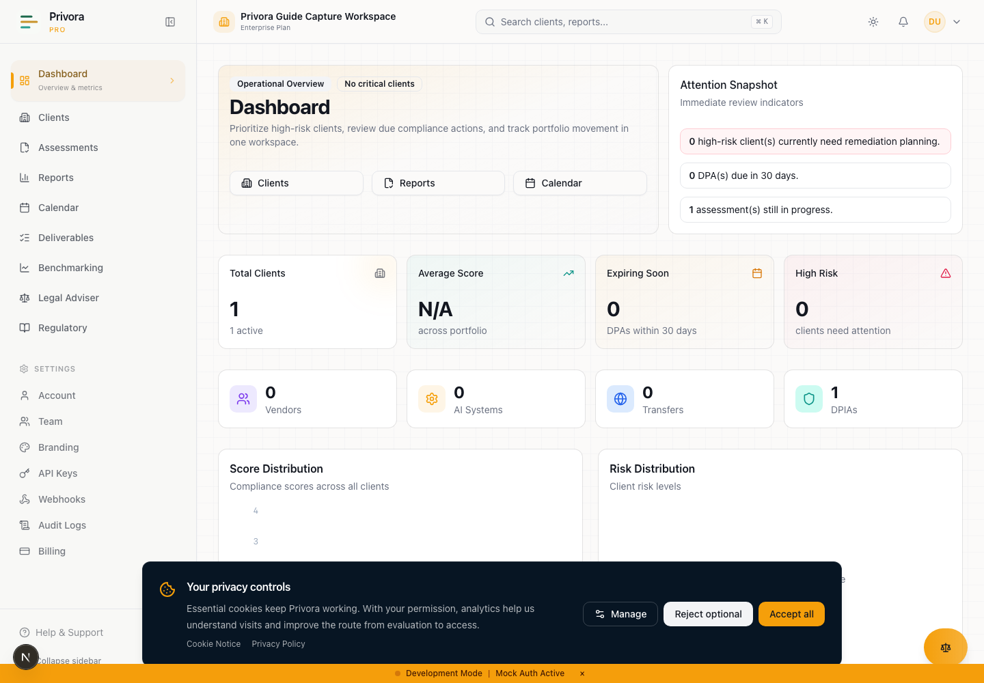
Use the Console dashboard overview view to continue the privacy operations workflow. 1. Operational overview badge
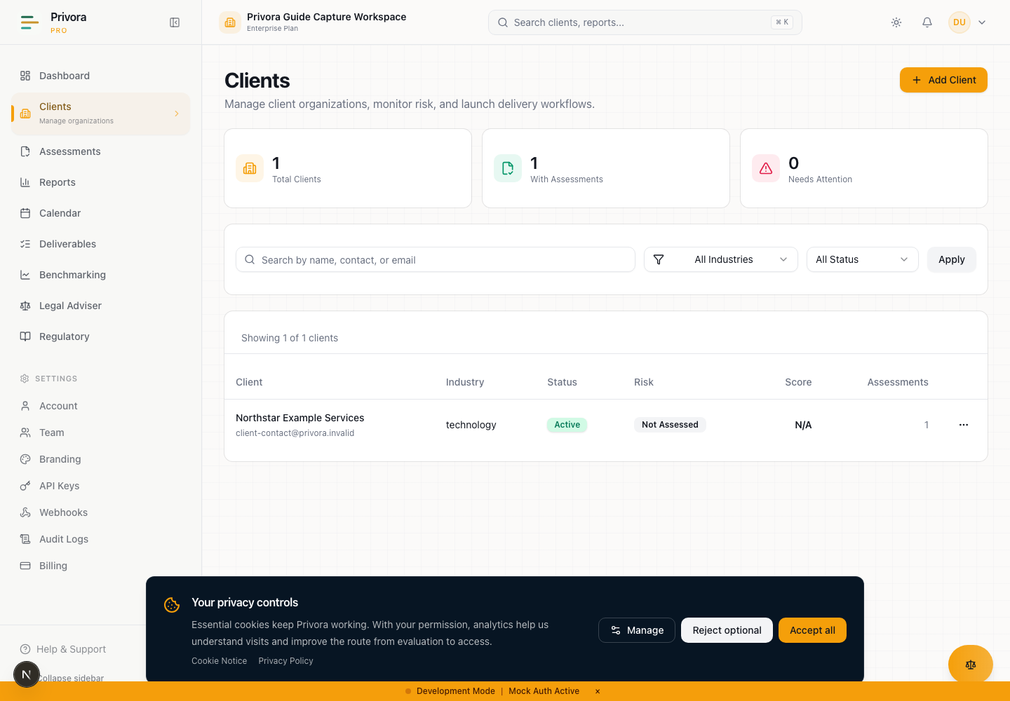
Use the Console clients list view to continue the privacy operations workflow. 1. Clients heading
How to reach this page
- 1. Start on the Console dashboard
- 2. Open the clients list workflow
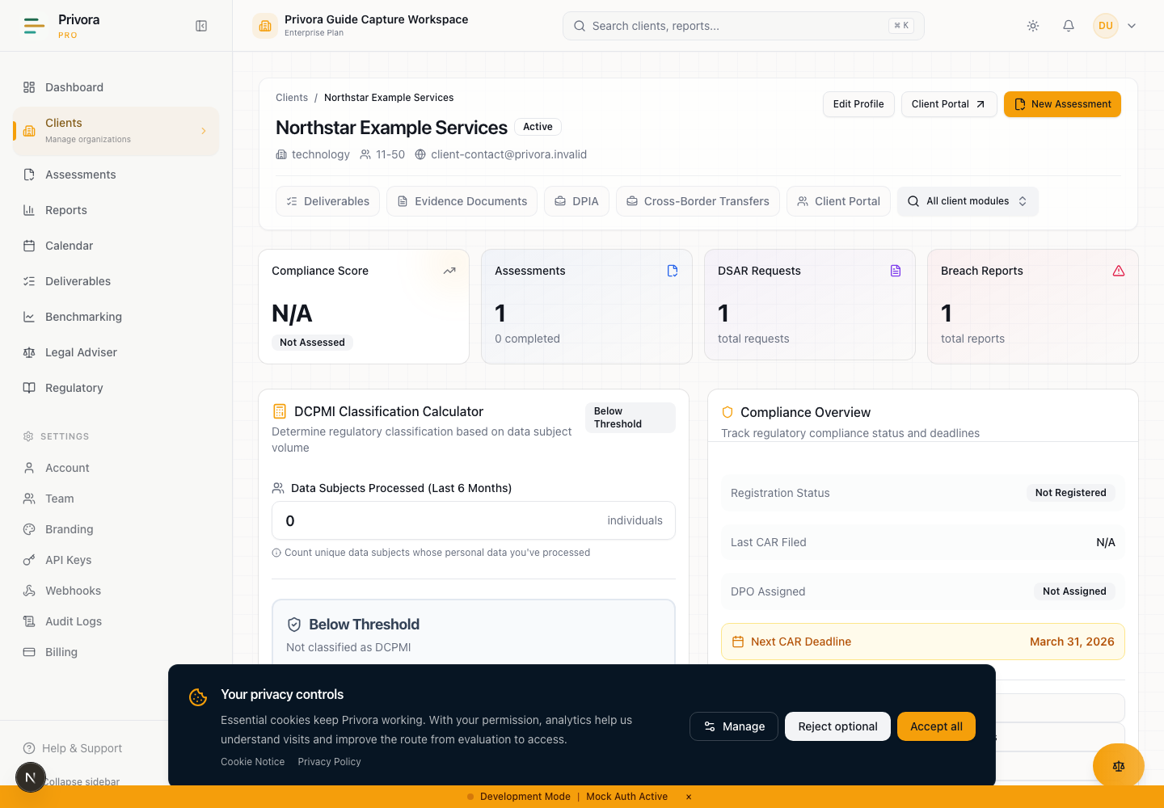
Use the Console client overview view to continue the privacy operations workflow. 1. Client name
Use this concise path inside authenticated console help when you need to operate the onboarding workflow without leaving Privora Pro. The engagement lead should read the outcome, confirm authority, move through all five stages, resolve exceptions, apply the completion gate, and update the operating record. The fuller runbook below provides preparation detail and examples; this path preserves the accountable method and does not reduce onboarding to a list of links.

Outcome and when to use it
Establish one reviewed baseline for the correct client: approved scope, one first workflow, named sponsor and delivery owner, least-privilege access, known evidence and gaps, managed dates, a first deliverable, and a scheduled review. Use this path for a new engagement, a new business unit, a controlled handover, or a material re-baseline. Do not delay an urgent breach, data-subject request, or other time-bound workflow while completing onboarding.

Roles and decision authority in console
The engagement lead operates the sequence and keeps records coherent. The client sponsor confirms business scope and client-side ownership. The DPO or privacy lead applies qualified judgment and decides when specialist review is needed. Assessors and evidence reviewers test information against defined criteria. Contributors provide scoped facts or files but do not approve conclusions through submission. An authorized Owner or Admin controls Team access. Verify organization, client, person, role, and business need before granting access or assigning work.

Five-stage onboarding path
Stage 1 — open the correct Client and confirm the boundary, scope, exclusions, sponsor, delivery owner, first workflow, and first review date. Stage 2 — review Team and client Portal access, apply least privilege, and keep access authority separate from decision authority. Stage 3 — establish the Documents evidence baseline, distinguish reviewed, unreviewed, outdated, and missing items, and start an Assessment only for the confirmed client and purpose. Stage 4 — load managed dates in Calendar and define the first Deliverable with inputs, reviewer, approver, and completion condition. Stage 5 — run the kickoff as a decision review, record approval, conditions, clarification, or deferral, then assign the next actions with owners and dates.

Exceptions and escalation path
Pause the affected action when scope, tenant boundary, access, evidence ownership, or decision authority is unclear. Escalate scope to the commercial and engagement authorities; access to an Owner or Admin; evidence conflicts to the accountable owner and reviewer; and legal, regulatory, sector, privilege, or material-risk questions to qualified professionals. Record the issue, consequence, interim control, decision owner, and review date. Never move a record across client boundaries as a workaround.

Completion and review gate
Complete onboarding only when the client boundary, scope, first workflow, roles, access decisions, evidence states, priority gaps, dates, deliverable, exceptions, and first review are traceable. A meeting, upload, or opened Assessment is activity, not completion. Review the baseline during the first 30 days as evidence arrives and ownership changes; keep open work visible with an accountable owner and next date.

Privora Pro record handoff
Use Clients as the anchor, Team for organization roles, Portal for scoped client participation, Assessments for structured assessment work, Calendar for managed dates, Documents for evidence and review, Deliverables for client-facing outputs, and Audit History for authorized traceability. Enter approved records in those surfaces, link related work instead of duplicating sensitive content, and perform a final organization/client/owner/review-date check. Preparation notes and the workbook do not become a second final record.

The operating outcome
The outcome is a usable client operating baseline: everyone knows the engagement scope, the first workflow to run, who is accountable, who may contribute, what evidence already exists, what is missing, which deadlines matter, and what will be reviewed first. The baseline should be specific enough for delivery to begin and compact enough to review with the client sponsor.
This method improves a common workflow problem. New engagements often arrive as a proposal, a folder of mixed files, several email introductions, and an assumed list of obligations. Nobody has yet joined those inputs into one operating record. The engagement lead spends time translating between commercial scope, privacy work, client ownership, and reporting expectations. Contributors receive broad requests. Senior reviewers see progress late.
The improvement is to establish one sequence: confirm scope, assign authority, set access, build an evidence baseline, load deadlines, choose the first deliverable, and review the decision with the sponsor. Privora Pro then holds the approved records and activity history. This is better because each next action has an owner, context, due date, and review point. It reduces operational complexity by replacing repeated reconciliation across inboxes, spreadsheets, shared folders, and meeting notes.
A complete baseline does not mean every gap is resolved. It means the team can distinguish known facts, missing evidence, assumptions requiring validation, and decisions requiring accountable review. That distinction is the foundation of review readiness.

When to use this runbook
Use the runbook when a DPCO begins a new client engagement, when an in-house privacy team establishes a new business-unit workspace, when responsibility moves to a new engagement lead, or when an existing client record needs a controlled re-baseline. It is also useful after a material scope change, merger, new operating geography, new regulated service, or prolonged period without reliable ownership.
Do not use onboarding to bypass a live incident, active data-subject request, or another time-bound workflow. Record and triage urgent work in the relevant workflow first. The baseline can then capture the continuing owners, evidence, and review cadence. Do not delay a required professional or regulatory decision merely to complete every kickoff page.
Start with one real workflow rather than attempting to catalogue every privacy topic at once. A focused first workflow gives the sponsor a visible result, exposes ownership gaps early, and teaches contributors how Privora Pro will be used. Suitable starting points include an assessment, a defined evidence review, a deadline-controlled deliverable, or another implemented client workflow agreed by the accountable lead.
Before proceeding, confirm that the commercial engagement permits the intended work, the correct Privora organization is active, the client record is or will be created by an authorized team member, and the sponsor can validate scope and ownership. If any of these conditions is unclear, pause the affected step and record the question for escalation.

Roles and decision authority
The client sponsor is accountable for confirming the client-side purpose, business context, senior ownership, and access to appropriate contributors. The sponsor can confirm that the baseline represents the organization, but should not be assumed to make every specialist privacy, security, records, legal, or operational decision.
The engagement lead or delivery owner is accountable for orchestrating the onboarding sequence, maintaining a coherent Privora Pro record, assigning work, and bringing unresolved decisions to the right authority. This role owns process quality. It does not inherit the client's management authority or replace qualified professional judgment.
The DPO or privacy lead reviews privacy-specific assumptions, determines when specialist review is required, and confirms the appropriate decision path. An assessor may conduct a baseline assessment and identify gaps, but an assessment score or system status is not itself an approval. Evidence reviewers decide whether submitted material is sufficient for the stated purpose. Contributors provide scoped facts or evidence and do not receive approval authority merely because they can upload or complete a task.
The Privora organization Owner or Admin manages team-level access according to current permissions. Team roles must be assigned on a least-privilege basis. Client portal users belong to one client context and receive only the access needed for assigned work. Client sponsorship, console membership, and portal participation are different authorities; do not blur them in a single generic “owner” label.
Use a simple authority statement for each material decision: who prepares, who reviews, who decides, who is informed, and who records the result. Where the same person performs more than one role, retain the role distinction in the record. This makes conflicts, missing review, and handoff risk visible.
Role | Accountable contribution | Authority boundary
Client sponsor | Confirms business scope and client-side owners | Does not automatically approve specialist conclusions
Engagement lead | Runs the workflow and maintains the operating record | Escalates decisions outside the delivery mandate
DPO or privacy lead | Applies qualified privacy judgment | Does not rely on system status as a legal conclusion
Assessor or evidence reviewer | Tests facts and evidence against defined criteria | Records review outcome; does not invent missing support
Client contributor | Supplies assigned facts, context, or evidence | Cannot approve the team's conclusion through submission
Organization Owner or Admin | Controls team access and role assignment | Uses least privilege and verified tenant context

Before kickoff
Collect only the minimum preparation material needed to conduct a useful kickoff: the agreed service scope, client legal and operating names, named sponsor, expected delivery owner, a high-level list of relevant systems or business areas, known deadlines, current evidence locations, and the proposed first workflow. Mark each item as confirmed, provisional, or unknown.
Verify the tenant boundary before entering client information. The user must be signed into the intended Privora organization, and the selected client must match the engagement. Similar client names, group companies, subsidiaries, and shared service entities require extra care. If the correct boundary is uncertain, do not copy records from another client or create a duplicate as a workaround. Ask an authorized Owner or Admin to resolve the organization and client context.
Agree how sensitive material will move. The workbook can prepare decisions, but passwords, authentication material, complete identity files, raw special-category datasets, or live incident payloads do not belong in kickoff notes. Use approved client systems and the authorized Privora Pro document workflow for operational records. Record a safe description or reference instead of duplicating sensitive content.
Set a bounded agenda. The meeting should confirm scope, roles, access, evidence baseline, deadlines, first deliverable, review cadence, and unresolved decisions. Send contributors only the portion they need. The full console operating view is for authorized DPCO or privacy-team members; there is no portal version of this onboarding runbook.

Stage 1 — Confirm scope and the first workflow
Begin in Clients with the correct client record. Confirm the client name, sector or operating context, primary contact, engagement status, and other fields the team actually uses. Treat the client page as the anchor for work performed for that client, not as a substitute for the signed engagement or a legal-entity register.
Write a one-sentence operating scope that names the workflow, organizational boundary, initial period, and expected output. For example: establish the evidence baseline for the agreed assessment and prepare the first reviewed gap summary for the sponsor. Avoid broad statements such as “make the client compliant.” They cannot be assigned, measured, or responsibly approved.
Select one first workflow and define its entry and exit conditions. For an assessment, identify who will answer, who will review, and what happens after completion. For an evidence cycle, define the request set and acceptance criteria. For a deliverable, name the input decision and required approval. Record work outside the current engagement as excluded, deferred, or subject to a separate decision.
Confirm the client-side sponsor and delivery owner before opening multiple workstreams. If an owner is not available, record the gap as a kickoff decision; do not distribute unowned tasks in the hope that somebody adopts them. Agree a date for the first review and a short statement of what will be ready for that review.
Open the client record · Privora Pro console
The output of Stage 1 is an approved scope statement, one named first workflow, explicit exclusions, a sponsor, a delivery owner, and a first review date. If scope remains disputed, the engagement lead should not present the baseline as approved.

Stage 2 — Assign roles and least-privilege access
Map the work roles before granting access. Decide which Privora team members need console access, which client people need portal access for assigned contributions, and which stakeholders need updates without direct system access. Access should follow responsibility; it should not be used as a substitute for defining responsibility.
Review Team settings with an authorized Owner or Admin. Assign the narrowest role that permits the expected work. Confirm that people who can manage team members, view audit records, or change client records genuinely need those capabilities. When responsibility changes, update access promptly rather than leaving dormant or inherited access in place.
Review team roles
For client contributors, review Portal settings within the correct client. Enable or use portal access only when the engagement needs client self-service collaboration. Confirm each portal user belongs to the intended client, has an active role appropriate to the assignment, and understands that task completion or file submission is a contribution, not a privacy-team approval.
Review client portal access · Privora Pro console
Perform a tenant-boundary check before invitations or assignments: organization, client, person, role, and intended task must all align. Use a second reviewer for ambiguous group structures, similarly named entities, or external consultants serving several clients. Never reuse a client task, document, or portal identity across client boundaries.
Record the authority map separately from the access map. A person may have technical permission to act but still require a sponsor, DPO, or engagement-lead decision under the agreed operating model. Conversely, a senior sponsor may hold decision authority without needing daily console access. The output is a reviewed role map, an access decision for each participant, and an owner for access removal.

Stage 3 — Establish the evidence baseline
Create an evidence inventory at the level needed for the first workflow. For each expected item, record its purpose, accountable owner, current location, relevant period, approval context, review status, and next action. Do not begin by moving every file. Begin by understanding what each item is expected to demonstrate.
Use Documents for authorized uploads and operational document records. The current product distinguishes pending, approved, rejected, and other lifecycle states and supports review context. A file name alone does not establish sufficiency. Preserve the business period, source, owner, version, and relationship to the request or requirement.
Review client documents · Privora Pro console
Classify each baseline item as available and current, available but unreviewed, outdated, missing, inaccessible, outside scope, or requiring specialist judgment. A concise and honest inventory is better than a large folder presented as complete. Record conflicting versions as a review issue rather than silently selecting one.
If the first workflow is an assessment, use Assessments to start it only after confirming the correct client and responsible assessor. An assessment structures questions and results; it does not remove the need to verify evidence, resolve exceptions, or obtain accountable review. Avoid starting duplicate assessments merely because ownership is unclear.
Start the client assessment · Privora Pro console
Prioritize gaps by their effect on the first workflow and upcoming decision. Separate “evidence absent” from “evidence exists but has not been reviewed.” Name the owner and next action for each priority gap. The Stage 3 output is a traceable baseline, not a claim that all evidence is current or adequate.

Stage 4 — Load deadlines and first deliverables
Translate agreed dates into an operating calendar. Include the first review, contributor due dates, evidence-review dates, expected decision dates, and deliverable approval date. Where a date depends on a legal or regulatory interpretation, record the source and obtain qualified review rather than presenting an assumption as a statutory fact.
Use Calendar to create or review the events that the team will actively manage. Give each event a clear title, client context, owner, priority, and action. Avoid duplicating the same date in multiple records without naming which record controls. If a date changes, record the reason and communicate the change to affected owners.
Open the operating calendar
Define the first deliverable in terms of audience, purpose, inputs, reviewer, approver, format, and completion condition. Examples include a reviewed baseline summary, assessment result discussion, evidence-gap register, or first operating report. Do not promise a report before naming the evidence and decisions it will rely on.
Use Deliverables to track the client-facing output where the implemented workflow applies. A generated or drafted item remains subject to review. Distinguish preparation, review, approval, and delivery so stakeholders do not treat an early artifact as final.
Review client deliverables · Privora Pro console
The output is a short deadline register and a defined first deliverable with one accountable owner and one approval route. Escalate dates that cannot be supported by available people, evidence, or authority.

Stage 5 — Run the kickoff review
Run the kickoff as a decision review, not a presentation of unchecked information. Start with the operating outcome and scope. Confirm the first workflow, sponsor, delivery owner, contributor roles, access decisions, evidence baseline, priority gaps, calendar, first deliverable, and first-30-day cadence.
For each disputed point, record one of four outcomes: approved, approved with a named condition, returned for clarification, or deferred to a named authority by a specific date. Do not convert silence into approval. Read back material decisions and confirm who will record them in Privora Pro.
Review client and tenant boundaries explicitly. Ask whether the record covers the intended legal entity, business unit, or operating scope; whether any evidence belongs to another entity; and whether portal contributors are attached only to the correct client. Resolve boundary questions before broad evidence requests or cross-team access.
End with the next seven days of work. Each action needs an owner, due date, expected output, and escalation point. Keep the sponsor's commitments separate from the delivery team's internal tasks. Schedule the first operating review while participants are present.
After the meeting, update the authoritative Privora Pro records and share a concise decision summary through the approved channel. Avoid retaining parallel “final” kickoff records in several locations. If preparation notes contain unapproved statements, mark or dispose of them according to the organization's records practice.

Exceptions and escalation
Escalate scope conflict to the commercial and engagement authorities when requested work falls outside the agreed mandate. Do not hide material scope expansion in a task description. Record the affected workflow, consequence, interim control, decision owner, and target date.
Escalate access uncertainty to an organization Owner or Admin. Suspend the invitation or assignment when client identity, tenant membership, role, or business need cannot be confirmed. Access convenience is not a reason to weaken the boundary.
Escalate missing or contradictory evidence to the accountable business owner and evidence reviewer. State what was requested, what was received, why it is insufficient or uncertain, what clarification is needed, and what decision is blocked. Do not rewrite a contributor's evidence to make it appear complete.
Escalate regulatory interpretation, legal privilege, sector-specific obligations, material risk, or disputed authority to appropriately qualified professionals. Privora Pro organizes the workflow and history; it does not make the professional decision.
For urgent operational work discovered during kickoff, create or open the relevant workflow and assign an owner immediately. Keep the onboarding baseline connected to that work through a safe reference. Do not copy sensitive incident or identity material into general kickoff notes.

Completion criteria
Onboarding is complete when the correct client and tenant context are confirmed; the scope and first workflow are approved; sponsor, delivery owner, reviewers, and contributors are named; least-privilege access decisions are recorded; the evidence baseline distinguishes reviewed, unreviewed, missing, and outdated items; priority gaps have owners; dates are loaded; the first deliverable and approval route are defined; and the first operating review is scheduled.
Completion also requires unresolved exceptions to have named decision owners and dates. A kickoff can close with open work, but not with invisible work. The engagement lead should be able to answer: what happens next, who owns it, what evidence supports it, what is blocked, and when it will be reviewed.
Do not mark the baseline complete merely because a meeting occurred, an assessment was opened, or files were uploaded. Those are activities. Completion is the reviewed operating state that connects authority, evidence, decisions, deadlines, and the next reportable outcome.

The first 30 days
During days 1–7, validate the client record, scope, role map, access, first workflow, and priority evidence requests. Resolve high-risk tenant or authority questions before expanding participation. Confirm the first review date and communicate the next actions.
During days 8–14, review received evidence, update the gap view, progress the assessment or first workflow, and address returned work. The engagement lead should check overdue items and remove ambiguous requests. The DPO or reviewer should identify any issue requiring specialist judgment.
During days 15–21, prepare the first deliverable from reviewed information. Separate facts, assumptions, gaps, recommendations, and decisions. Confirm the intended audience and approval route. Reconcile the calendar and evidence status before circulating the draft.
During days 22–30, conduct the operating review with the sponsor. Approve or return the deliverable, assign next-quarter or next-cycle owners, update access if responsibilities changed, and capture lessons. The goal is a repeatable rhythm, not a one-time onboarding event.
Use this cadence as an operating pattern, not a claim that every engagement must finish in thirty days. Client complexity, availability, evidence quality, urgent workflows, and professional review can change the sequence. Record the reason when the team adapts it.

Record the work in Privora Pro
Use Clients as the client anchor, Team for organization access, Portal for scoped client participation, Assessments for structured assessment work, Calendar for managed dates, Documents for evidence records and review, Deliverables for client-facing outputs, and Audit History for traceability available to authorized roles.
Review Audit History when you need to verify material client, assessment, report, or team events. Audit records support accountability, but they do not replace the decision rationale that belongs in the workflow record. Keep descriptions professional, minimal, and free of unnecessary sensitive information.
Review audit history
Enter approved scope, roles, deadlines, evidence status, decisions, and deliverable state in the relevant Privora Pro surfaces. Link or safely reference related records instead of duplicating their contents. Treat preparation workbooks and meeting notes as aids; Privora Pro remains the operating record after approved information is entered.
Before closing the onboarding cycle, conduct a final boundary check: correct organization, correct client, current access, named owner, reviewed evidence status, approved next action, and visible review date. This short control prevents a well-run meeting from becoming an unreliable system record.

Sources and professional review
Product behavior and routes were reviewed against the current Privora Pro workflow source of truth and implemented pages on 2026-08-12. The brand and product-marketing sources define Privacy Operations as the category and require workflow-led, evidence-led, legal-safe language. No statutory deadline is asserted by this runbook.
Privora Pro workflow source of truth · Implemented workflow architecture and current product routes; reviewed 2026-08-12
Privora brand identity · Privacy Operations category, positioning, voice, and claim boundaries; reviewed 2026-08-12
Privora product marketing context · Audience, workflow problems, operational differentiation, and customer language; reviewed 2026-08-12
Apply current client agreements, internal policies, verified regulatory sources, and qualified professional judgment to the particular engagement. When product behavior, internal documentation, client facts, or regulatory material conflict, stop the affected instruction, record the conflict, and resolve it with the appropriate authority before presenting the step as approved.

