

PRIVACY OPERATIONS · PRIVORA PRO · RUNBOOK
Run a quarterly client review with evidence and accountable ownership
Prepare one evidence-led review of open work, decisions, deadlines, deliverables, and next-quarter ownership.
Primary action
Open the client workspace and prepare the quarterly review pack.
Version: 1.0.0
Reviewed: 2026-08-12
https://docs.privora.ng/pro/operating-library/quarterly-client-review

Important legal and use notice
Title: Run a quarterly client review with evidence and accountable ownership
Version: 1.0.0
Reviewed: 2026-08-12
Canonical URL: https://docs.privora.ng/pro/operating-library/quarterly-client-review
Purpose
This document is a Privora operational resource designed to help teams organize privacy work, evidence, ownership, review, and reporting.
Not legal advice
This document provides general operational guidance. It is not legal advice and does not replace advice from qualified legal or regulatory professionals.
No guarantee
Use of this document or Privora does not guarantee compliance with any law, regulation, standard, or contractual obligation.
Current requirements
Laws, regulatory guidance, product workflows, and organizational obligations may change. Users are responsible for confirming the current requirements that apply to their circumstances before acting.
Generated and reviewed material
This document was generated by Privora from the canonical operating kit identified on this page. Human review remains required before the document is relied upon or shared.
Data handling
Do not enter personal, sensitive, privileged, or confidential information into uncontrolled copies. Store approved operational records only in authorized systems and follow your organization’s access, retention, and handling policies.
Use and intellectual property
© 2026 Privora. Privacy Operations. Use, copying, modification, and redistribution are subject to applicable Privora terms, licences, and permissions.
Change notice
This document reflects the version and reviewed sources identified on this page. Product workflows and authoritative guidance may change, and a later release may supersede this document.

Run a quarterly client review with evidence and accountable ownership

Product walkthrough
Start on the Console dashboard, open the client workspace, and review Deliverables, Reports, Calendar, and Audit History in that order. Use the screenshots to orient yourself before preparing the review pack; the guide presents only public route templates and labels, not internal record identifiers.
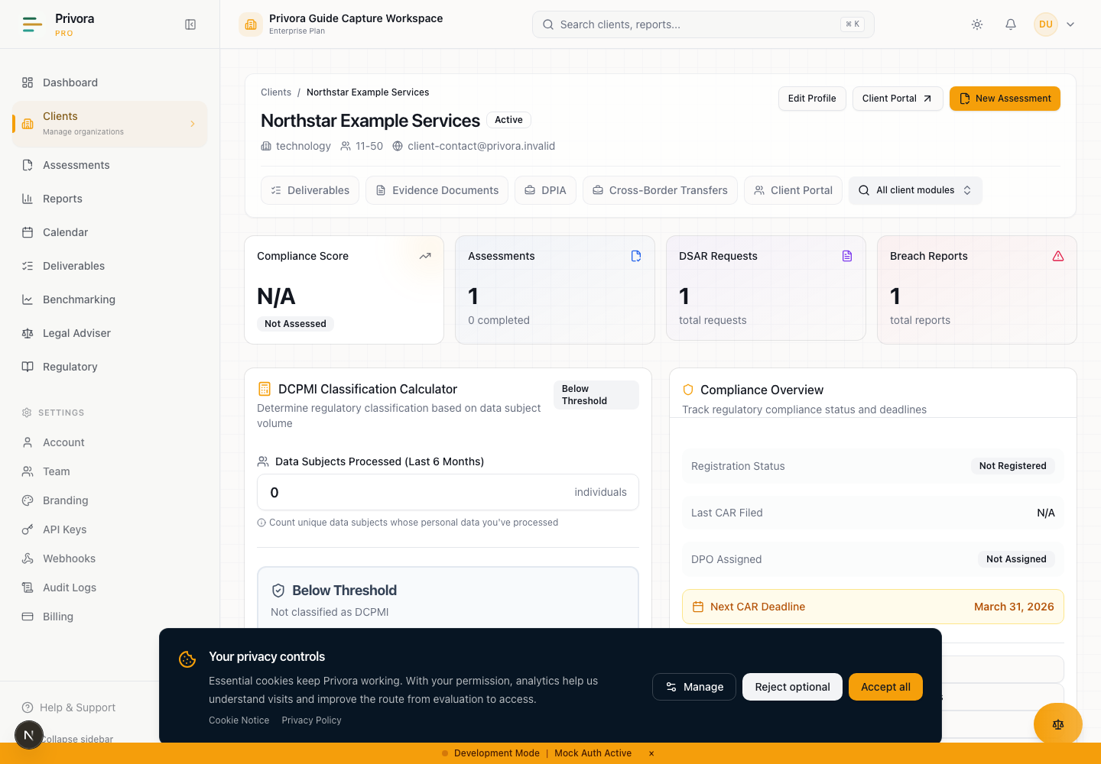
Use the Console client overview view to continue the privacy operations workflow. 1. Client name
How to reach this page
- 1. Start on the Console dashboard
- 2. Open the client overview workflow
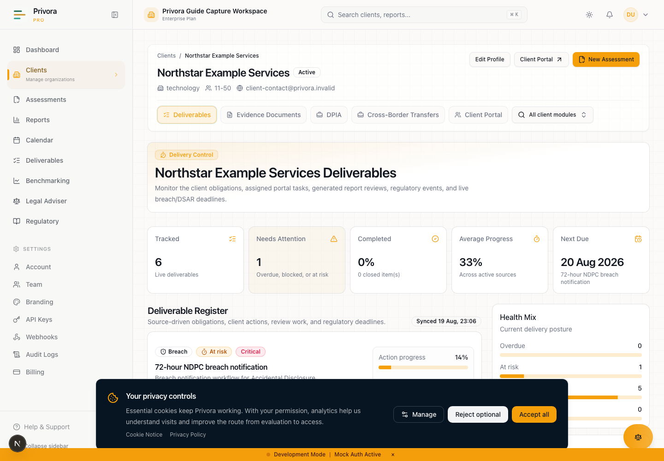
Use the Console deliverables view to continue the privacy operations workflow. 1. Deliverables heading
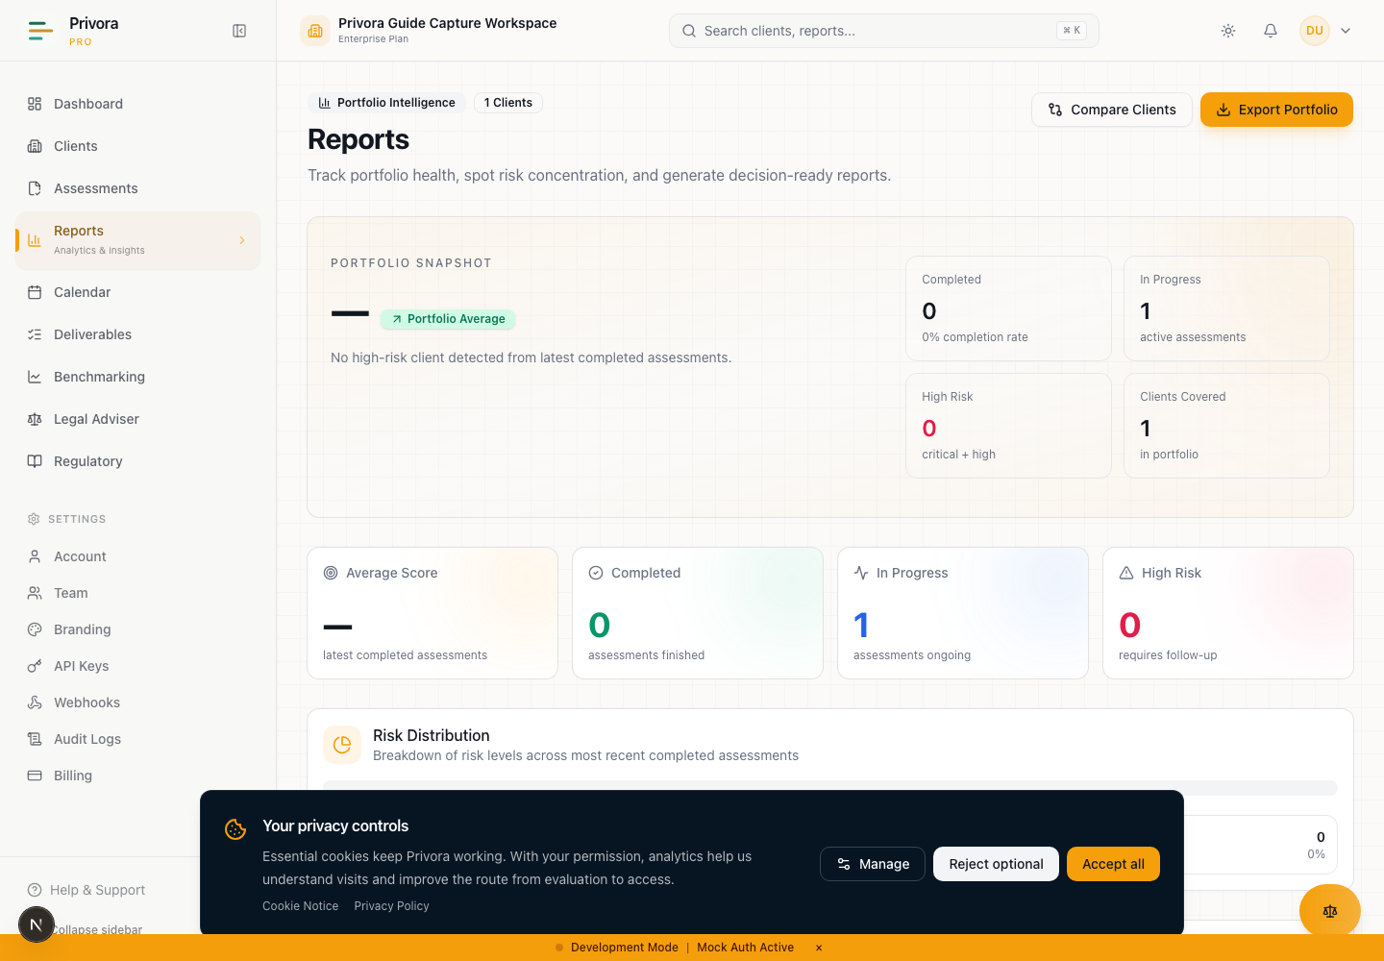
Use the Console reports view to continue the privacy operations workflow. 1. Reports heading
Operational guidance — not legal advice. This guide does not guarantee compliance.
This runbook structures a recurring Privacy Operations review. It does not replace qualified advice, certify evidence, or turn an unreviewed product output into an approved client deliverable.
Treat draft review packs as confidential client work. Verify the tenant and client before reviewing or exporting records. Keep personal data and restricted evidence in their authorized systems. Use references and approved summaries in the meeting pack.

The operating outcome
A quarterly client review should convert operational evidence into decisions and owned follow-up. It is not a presentation exercise and not a generic health score. The completed workflow gives the DPCO team, DPO, engagement owner, and client sponsor a common view of open requests, overdue work, evidence health, assessments, material risks, regulated workflows, deadlines, decisions, approved deliverables, and next-quarter priorities.
The workflow improves recurring client governance. It is designed for teams managing one client or a portfolio of clients who need consistent review quality without rebuilding the method every quarter. It is better than a status meeting assembled from email because the review begins with scoped source records, separates fact from interpretation, identifies accountable owners, and ends with an approved operating plan.
The business outcome is clarity: what was reviewed, what remains unresolved, which evidence can support a decision, what requires escalation, which report has been approved, and who owns the next action. The complexity reduction comes from using one sequence and one evidence discipline across clients while allowing the underlying risks and priorities to remain client-specific.
The minimum outputs are a reviewed portfolio snapshot for the client, an open-work decision list, an evidence-health view, a regulated-workflow review, a deadline plan, an owner commitment register, an approved client report, and a next-quarter operating plan. Generated reports remain drafts until an authorized reviewer approves them. The approved report should state its period, source basis, limitations, owner, and approval date.
Do not invent performance metrics, savings, completion claims, maturity improvements, or outcome trends. Report only values and changes supported by current Privora records or another named authoritative source. Where the source cannot support a comparison, describe the operational fact without manufacturing a number.

When to run the review
Run the review on an agreed quarterly cadence and whenever a material event makes the normal cadence insufficient. The engagement charter should identify the review period, preparation lead time, meeting participants, approval authority, and client delivery date. Add the review and preparation milestones to the calendar rather than relying on memory.
A quarterly review is useful when the team needs to reconcile work across assessments, evidence, risks, DPIAs, data subject requests, breaches, vendors, transfers, portal tasks, generated documents, and client deliverables. It is also a control point for decisions that have remained open because information, authority, budget, or ownership was missing.
Do not wait for the quarterly meeting to manage urgent incidents or legal deadlines. Breaches, data subject requests, critical evidence gaps, high residual risk, and overdue obligations continue in their dedicated workflows. The review summarizes and escalates them; it does not suspend or replace their operating controls.
Begin preparation early enough to request corrections and obtain approvals. Freeze the reporting cut-off date, but do not hide relevant events that occur after cut-off. Record later events as subsequent matters with their own owner and workflow. If a meeting is delayed, preserve the original reporting period and reset only the meeting date and downstream commitments.
The review is complete only when decisions and commitments are captured after the meeting. Attendance or a circulated slide deck is not completion. If the sponsor cannot approve the report, record the outstanding approval and keep the deliverable in draft or review status.

Roles and decision authority
Portfolio or DPCO lead: owns review quality across engagements, confirms the method, resolves cross-client resource conflicts, and escalates material delivery risk. Portfolio access does not justify exposing one client's information to another.
Engagement owner: prepares the client review, confirms scope and source records, coordinates specialists, records decisions, and owns delivery of the approved output. The engagement owner should challenge stale, unsupported, or contradictory statements before the meeting.
DPO or privacy lead: interprets privacy risk, reviews regulated workflows, preserves independent advice, and identifies matters requiring professional judgment. The DPO should not be asked to approve business claims outside the evidence reviewed.
Evidence reviewer: assesses relevance, sufficiency, currency, ownership, and approval status. An uploaded document is not automatically sufficient evidence. The reviewer records limitations and returns weak items through the appropriate evidence workflow.
Workflow owners: provide accurate status for assessments, DPIAs, data subject requests, breaches, vendors, transfers, remediation, and deliverables. They remain accountable for their records after the quarterly meeting.
Client sponsor: confirms business priorities, resolves ownership and resource decisions, approves the client-facing report within delegated authority, and accepts or escalates material residual risk. Sponsor approval does not replace DPO review where professional judgment is required.
Report preparer and approver: must be distinct where governance requires separation. The preparer assembles the draft and source references. The approver confirms facts, limitations, decisions, and audience before external circulation.
Name a facilitator, note taker, timekeeper, and decision owner for the meeting. Clarify who may change a status, approve a deliverable, accept a risk, commit resources, or communicate externally. If the required authority is absent, record a recommendation and approval due date rather than pretending a decision was made.

Stage 1 — Prepare the review pack
Define the client, reporting period, cut-off date, meeting date, intended audience, and decisions required. Confirm that every source belongs to the correct tenant and client. Use the dashboard for portfolio-level orientation, then return to the client workspace for client-specific facts.
Build a source register rather than copying every record into a new document. Include the source area, record owner, reporting cut-off, last update, reviewer, and limitation. The pack may draw from the client overview, deliverables, evidence and document review, assessments, risk records, DPIA, DSAR, breach, vendor, transfer, calendar, reports, and activity history where implemented and relevant.
Reconcile the prior quarter's commitments first. For each commitment, identify the original decision, owner, due date, current evidence, status, blocker, and proposed disposition. Do not call an item complete because a meeting note says so. Link or reference the reviewed completion evidence.
Prepare an exception list for missing records, stale evidence, contradictory status, inaccessible owners, unresolved approvals, and system limitations. A transparent gap is more useful than a polished but unsupported summary. Assign a pre-read owner for each exception and decide whether it blocks the report or can be carried with a clear limitation.
Draft the agenda around decisions, not modules. Group items by attention required: approve, decide, escalate, note, or monitor. Send a controlled pre-read to authorized participants. The stage output is a scoped review pack, source register, prior-commitment reconciliation, exception list, and decision-led agenda.

Stage 2 — Review open requests and overdue work
Start with work that is waiting for a person, evidence, review, or decision. Use client deliverables and relevant task views to identify not-started, in-progress, blocked, submitted, completed, overdue, or waived items. Confirm that each label reflects current evidence and the correct workflow.
For every overdue item, record the obligation or operating purpose, original due date, accountable owner, current blocker, impact, interim control, revised commitment, and escalation authority. Do not normalize repeated lateness by moving dates without preserving the prior commitment. If a date was incorrect, record the correction and its source.
Review returned or repeatedly incomplete evidence requests. Determine whether the request was unclear, the owner lacked access, acceptance criteria were missing, the evidence does not exist, or the reviewer has not acted. Choose a resolution: clarify, reassign, reduce scope, escalate the gap, or close with a documented reason.
Check open portal tasks only as source work assigned to the client. The quarterly report is a console-controlled client deliverable and has no portal authoring or approval path in this guide. Do not give contributors report approval authority through meeting attendance or task completion.
The stage output is an open-work register with accurate state, reason, owner, decision, and next date. Move urgent statutory or incident work back into its dedicated workflow immediately rather than waiting for the meeting to finish.

Stage 3 — Review evidence health and sufficiency
Assess evidence by control or decision area, not by file count. For each material item, review relevance, source, coverage period, owner, version, approval, integrity, accessibility, and whether it supports the stated conclusion. Distinguish approved evidence, submitted evidence awaiting review, partial evidence, stale evidence, rejected evidence, and missing evidence.
Use an evidence-age rule only when it matches the control. A current policy may still lack implementation evidence; an older signed contract may remain valid; a recent screenshot may be weak evidence. Explain why evidence is sufficient for the specific decision and period.
Identify concentration risk where one document, one system owner, or one unavailable person supports several conclusions. Confirm whether evidence can be reproduced and whether changes after the reporting cut-off affect reliance. Record sampling limits and unresolved contradictions.
Return weak evidence through the evidence workflow with precise acceptance criteria. Do not quietly omit it from the review. If missing evidence limits a report statement, qualify or remove the statement and add a commitment. Keep sensitive evidence in its authorized location and use a reference in the review pack.
The stage output is an evidence-health review that names material strengths, gaps, stale items, returned work, decision impact, and next owners. Avoid a decorative evidence score unless its definition, denominator, period, and source are approved and reproducible.

Stage 4 — Review assessments, risks, and regulated workflows
Review assessments using their actual status, completion record, scoring basis, evidence support, and unresolved findings. A score is one input, not a complete statement of compliance. Explain the period and assessment scope before comparing results.
Review open risks and remediation by severity, rights-and-freedoms impact, owner, treatment, evidence, residual position, due date, and escalation. Distinguish accepted residual risk from work that is merely delayed. Confirm that acceptance was made by the correct authority and remains current.
Review DPIAs for trigger coverage, data-flow facts, contributor evidence, treatment, residual-risk decision, prior consultation where applicable, certified DPO vetting where required, report status, and review date. Review data subject requests for deadlines, search ownership, restrictions requiring professional review, response approval, delivery, and closure evidence.
Review breaches for awareness and action timeline, risk decisions, communications, external delivery evidence, remediation, and closure. A product status does not prove regulator receipt. Review vendors and transfers for current ownership, contract/evidence position, risk decision, reassessment trigger, and open action.
Record regulated-workflow exceptions separately from routine tasks. If a workflow is outside the reporting period but materially affects current risk or next-quarter work, include it with a clear reason. The stage output is a reviewed regulated-workflow summary with source references, limitations, decision needs, and escalation.

Stage 5 — Review deadlines and deliverables
Use the calendar to inspect upcoming, overdue, in-progress, completed, and recurring events relevant to the client. Verify seeded or manually created dates against their authoritative source before relying on them. A calendar entry is a reminder and record, not proof of a legal requirement.
Review client deliverables by source type, health, status, due date, owner, audience, and approval state. Confirm how breach, DSAR, generated-document, portal-task, and calendar-event work has been synchronized. Resolve duplicates and ensure the most authoritative source remains clear.
Separate internal draft dates, reviewer dates, client approval dates, external delivery dates, and regulatory deadlines. Assign preparation and approval lead time. Escalate when a dependency makes the final date unsafe instead of compressing every review into the last day.
For completed deliverables, verify the approved version and evidence of delivery. For waived items, record who had authority, why waiver was appropriate, and when it should be reconsidered. For blocked items, identify the decision or resource needed, not only the person currently holding the task.
The stage output is a deadline and deliverable plan with verified dates, source references, owners, health, approval gates, and escalation points. Remove any unsupported deadline from the client report until it is verified.

Stage 6 — Resolve decisions and ownership
Convert observations into explicit decisions. A good decision record states the question, available options, evidence considered, recommendation, authority, decision, rationale, date, dissent, dependencies, and review trigger. If the decision is deferred, name the missing input, owner, and due date.
Review every material action for one accountable owner. A team, department, vendor, or client is not an adequate owner. Name the responsible role and confirm the individual or authorized queue that will act. Record alternates for time-sensitive commitments.
Resolve conflicts between the delivery team and client sponsor transparently. The engagement owner should not mark an item accepted merely to close the meeting. Preserve the DPO's professional view where it differs from a business decision and escalate through agreed governance.
Prioritize next actions by harm, legal or contractual timing, dependency, decision readiness, and operational leverage. Do not manufacture a numerical priority score unless an approved method exists. A short reason is often more reviewable than a pseudo-precise number.
The stage output is a decision register, owner commitment list, escalation record, and approval schedule. Read back decisions before the meeting closes so participants can correct misunderstandings while the context is current.

Stage 7 — Approve the client report
Assemble the report from the reviewed pack and decision record. State the client, period, cut-off date, sources, reviewers, limitations, open matters, decisions, commitments, and next review date. Separate confirmed facts from interpretation and recommendations.
Generated reports remain drafts until an authorized reviewer approves them. Generation, preview, download preparation, or a file name does not establish approval. Use the generated-document review workflow where applicable, resolve validation errors, record reviewer changes, and approve only when the factual and evidence basis is sufficient.
Do not imply that a report is a regulatory filing, legal opinion, or proof of compliance. Do not invent performance metrics. If a metric is included, define its source, period, scope, denominator, calculation, owner, and reviewer. If those controls are unavailable, use a factual narrative and named records instead.
Apply a final client-boundary check. Remove cross-client comparisons unless specifically authorized and safely aggregated. Remove internal deliberations that should not be circulated, but preserve the underlying decision history in the operating record. Confirm accessibility, clear labels, and meaningful status language.
Record approver identity, role, approval time, approved version, audience, delivery owner, and delivery evidence. If approval is conditional, state the conditions and keep the report out of final status until they are met. The stage output is one approved report or a clearly controlled draft with outstanding approval actions.

Stage 8 — Set the next-quarter operating plan
Translate the review into a bounded plan. Carry forward unresolved obligations, remediation, evidence requests, regulated-workflow reviews, vendor or transfer actions, training, governance decisions, and report improvements. Each item needs a purpose, owner, due date, completion evidence, dependency, and escalation path.
Limit priorities to work the team can actively govern. A long list without capacity decisions creates hidden failure. Ask the sponsor to resolve competing priorities, resource gaps, and decisions that block several actions. Record what is deferred and why.
Create calendar events and deliverables for the approved plan using the correct client context. Link each item to its originating decision or source workflow. Schedule evidence and decision reviews before final deadlines. Confirm who will monitor between quarterly meetings.
Define the next review's source cut-off, preparation owner, meeting date, and expected approvals. Record lessons about pack quality, meeting design, source availability, and decision speed. Improve the operating method without rewriting evidence history.
The stage output is an approved next-quarter plan, capacity and escalation decisions, calendar and deliverable entries, monitoring cadence, and next review schedule.

Portfolio escalation
Escalate to the portfolio or DPCO lead when a client matter creates material rights-and-freedoms risk, repeated overdue work, unresolved professional disagreement, missing sponsor authority, cross-engagement resource conflict, or a delivery-quality pattern. Preserve client isolation while describing the operational issue.
Portfolio review may identify a reusable process improvement, training need, template clarification, or staffing decision. It must not expose another client's facts, evidence, risk, or performance. Use anonymized pattern descriptions only when they remain accurate and authorized.
Where a current product surface is marked coming soon, do not represent it as available. Portfolio summary export and trend analysis are not operating instructions for this release. Use implemented dashboard, report, deliverable, calendar, and audit views, then prepare an approved client-specific report through the supported workflow.
Record the escalation question, owner, due date, decision authority, affected client work, interim control, and outcome. Return the decision to the client operating record so it does not remain in a separate management conversation.

Completion criteria
Complete the quarterly review when:
- client, period, cut-off, audience, sources, and limitations are documented;
- prior-quarter commitments are reconciled against reviewed evidence;
- open and overdue work has an accurate state, reason, owner, and next decision;
- material evidence has been assessed for relevance, sufficiency, currency, and approval;
- assessments, risks, DPIAs, DSARs, breaches, vendors, and transfers relevant to the period are reviewed;
- deadlines and deliverables are verified against source records;
- decisions, dissent, escalations, and owner commitments are captured;
- the client report is approved by the authorized reviewer or remains explicitly draft;
- no unsupported result metric or cross-client information appears in the deliverable;
- the next-quarter plan has owners, dates, evidence expectations, and escalation paths;
- the approved report and meeting decisions are recorded in the correct client workspace;
- the next review and interim monitoring cadence are scheduled.
If a blocking approval or material source gap remains, close the meeting but not the workflow. Retain the draft status and assign the completion action.

Record the work in Privora Pro
Begin with the dashboard for attention signals, then use the client workspace as the source for client-specific review. Use client deliverables for owned work and deadline health, reports for implemented portfolio and comparison views, the calendar for verified events, and audit logs for supported activity evidence. Return to the originating workflow for any correction.
Review the operational dashboard
Open the client workspace · Privora Pro console
Review client deliverables · Privora Pro console
Review implemented reports
Review verified deadlines
Review supported audit records
Record corrections in their authoritative workflow. Do not create a second status system in the report. Keep drafts labelled, preserve approval evidence, and record final delivery separately from generation.

Sources and professional review
Product instructions were reviewed on 12 August 2026 against current implemented Privora Pro routes and behavior. Brand and claim controls follow Privora's Privacy Operations positioning: evidence, ownership, review, reporting, and operational visibility are the method; reviewed operations remain the basis for accountable outcomes.
Privora Pro workflow source of truth · Implemented dashboard, client, deliverable, report, calendar, audit, regulated-workflow, and generated-document review behavior
Privora brand identity · Privacy Operations category, voice, evidence, ownership, review readiness, and claim boundaries
Privora product marketing context · Audience, workflow problem, operational improvement, complexity reduction, and prohibited claims
Obtain professional review for legal interpretations, regulated-workflow decisions, residual-risk acceptance, external assurance language, filings, sector duties, and material client disputes. Reverify product behavior before teaching a newly released action. This guide has no portal content because quarterly report preparation and approval remain console-controlled responsibilities.

